Gemeinsam die Zukunft gestalten- nachhaltig die Welt mitgestalten und Veränderungen vorantrieben- Project Title in English Shapingthefuturetogether - helpingtoshapetheworldsustainablyanddrivingchange
2023-2-HU01-KA220-SCH-000169980

Newsletter – September

International Cooperation and Joint Programs
A central element of the project was the Challenge Week – a thematic week on sustainability, jointly implemented by the partner schools. The aim of the program was to raise students’ environmental awareness and to promote sustainable lifestyles through hands-on activities.
Within the framework of the activities carried out in different countries, the students:
- participated in nature-based programs (excursions, plant observation),
- created useful objects from recycled materials,
- explored sustainable sports activities,
- and contributed to the design and maintenance of school gardens and green spaces.
The programs not only enhanced environmental awareness but also fostered collaboration, creativity, and a sense of responsibility among the learners.
https://padlet.com/nachhaltigkeithsig/woche-challenge-fe2nxwnwig9i0yox

Activities of the Hungarian School
The Hungarian partner institution also actively participated in the implementation of the project.
The school took part in the nationwide initiative “One Million Steps for Your School!”, which promotes physical activity and a healthy lifestyle.
To ensure the successful implementation of the program, student groups were reorganized, with class teachers playing a central role.
The institution organized and coordinated the Challenge Week activities and actively involved the students.
In addition, the development of a sustainable classroom was continued, supporting long-term environmental education and modern learning environments.

Activities of the Greek Partner School
The Greek school began planning sustainability-related activities at the very beginning of the school year.
Students collected materials they had created during the summer and produced a video on sustainable sports.
During the Challenge Week, various activities were carried out:
- walks and nature photography along the Pinios River,
- creation of objects from recyclable materials for the sustainable classroom,
- planting flowers and maintaining green areas in the schoolyard,
- sustainable physical activities (e.g., sack races, cycling).
Additionally, expert lectures enriched the program.
Students also participated in an initiative to reduce food waste and learned about the principles of of the circular economy.

Activities of the Italian Partner School
For the Italian partner school, the Challenge Week was of central importance.
During the week:
- more than 100 students participated in nature-based activities (hiking, walks),
- creative upcycling activities were carried out,
- sustainable sports competitions using recycled materials took place,
- and a school garden was established.
At the end of the week, the results were presented and shared in an online meeting, including photos, videos, and reports.
The program made a significant contribution to developing students’ environmental awareness, as well as strengthening collaboration and a sense of responsibility.

.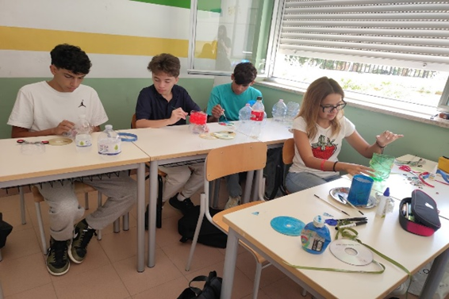

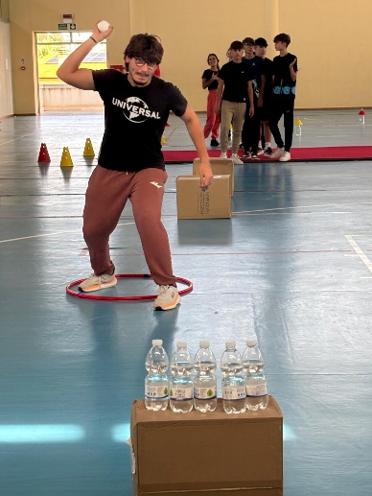
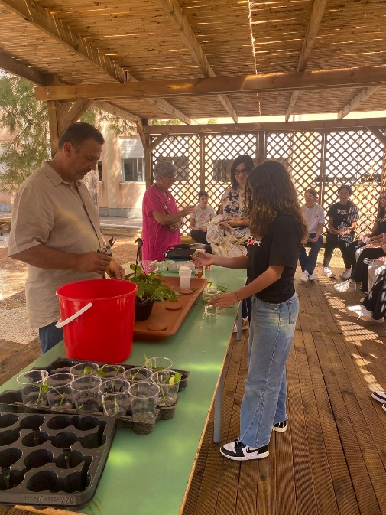

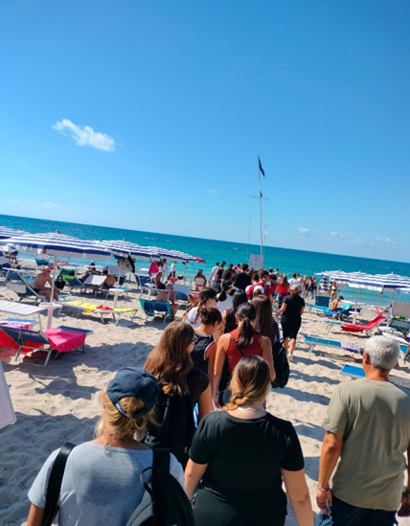

„Mit finanzieller Unterstützung der Europäischen Union. Die geäußerten Ansichten und Meinungen entsprechen jedoch ausschließlich denen der Autor*innen und spiegeln nicht notwendigerweise die der Europäischen Union oder der Tempus Közalapítvány wider. Weder die Europäische Union noch die fördernde Stelle können dafür verantwortlich gemacht werden.“
Projektnummer: 2023-2-HU01-KA220-SCH-000169980

