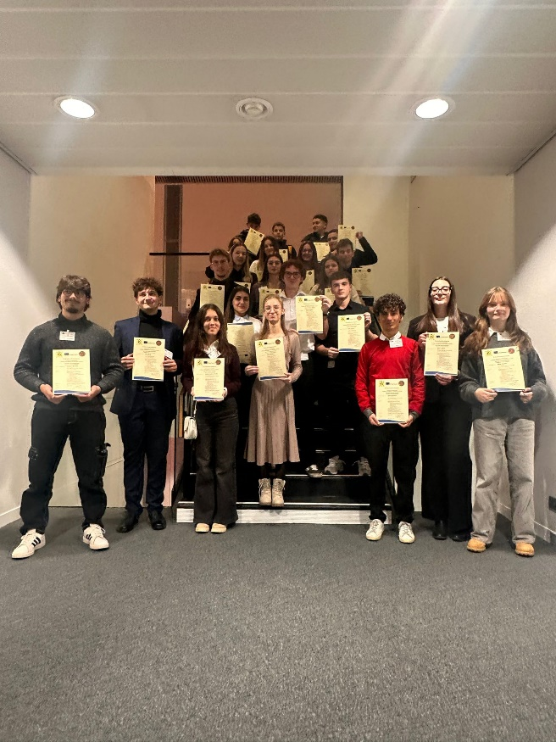
16. Newsletter –
Multiplication Week in Strasbourg
The final meeting of the Erasmus+ project “Shaping the Future Together – Actively Contributing to a Sustainable World and Driving Change” took place in Strasbourg. The academic program was deliberately aligned with sustainability goals and with the multiplier event organized at the European Parliament.
Strasbourg itself served as a pedagogical learning environment: the city is both a symbol of European cooperation and an example of sustainable urban development. All program activities reflected these two dimensions.
Following the arrival of the partners, an opening meeting was held, during which the results of the past 24 months of the project were reviewed. At the same time, the objectives of the final meeting were defined:
- the systematic presentation of project results,
- the integration of the sustainable learning environment model into a European context,
- the preparation of the multiplier event at the European Parliament.
During a guided city tour, participants analyzed Strasbourg’s sustainable transport system, green infrastructure, and energy-efficient solutions. Students worked using structured observation criteria and subsequently discussed the relationship between sustainability and European core values such as solidarity, responsibility, and intergenerational justice.
This activity served as preparation for the presentation at the European Parliament and highlighted that sustainability is not only an ecological issue, but also has social and democratic dimensions.
In the subsequent workshop, key project results were finalized:
- the handbook on sustainable learning environments,
- the results of measurements (ecological footprint, changes in attitudes and awareness),
- the documentation of structural developments within partner institutions,
- summaries of podcasts and student-produced outputs.
The aim was to prepare a scientifically sound presentation based on measurable results, which could be presented at the European Parliament.
The visit to Colmar also provided participants with intercultural experiences and exposure to European cultural diversity. This contributed to one of the project’s horizontal objectives: the promotion of intercultural competences and the development of a European identity.
During the visit to the European Parliament, participants gained insight into European decision-making processes, explored the plenary chamber, and engaged in professional exchange. This activity represented a concrete experience of active citizenship: students encountered European democracy not only theoretically, but within its real institutional framework.
The highlight of the final meeting was the multiplier event held at the European Parliament. The aim of this event was the European dissemination of the project results.
During the presentations:
- we presented our models of sustainable learning environments,
- we introduced the developed handbook and its transferability,
- we explained measurable indicators and project impacts,
- we reflected on the partnership’s cooperation models,
- we emphasized the role of young people in the context of ecological transformation.
The significance of this multiplier event lay in the fact that:
- the project results were presented in a European professional environment,
- the topic of sustainability was directly linked to the political priorities of the European Union,
- students had the opportunity to present their work in a real political decision-making setting.
The event was therefore not only a dissemination and multiplication activity, but also an important step towards the societal and institutional anchoring of the project results.
In the final meeting, further dissemination steps and perspectives for the sustainable continuation of the project outcomes were defined.
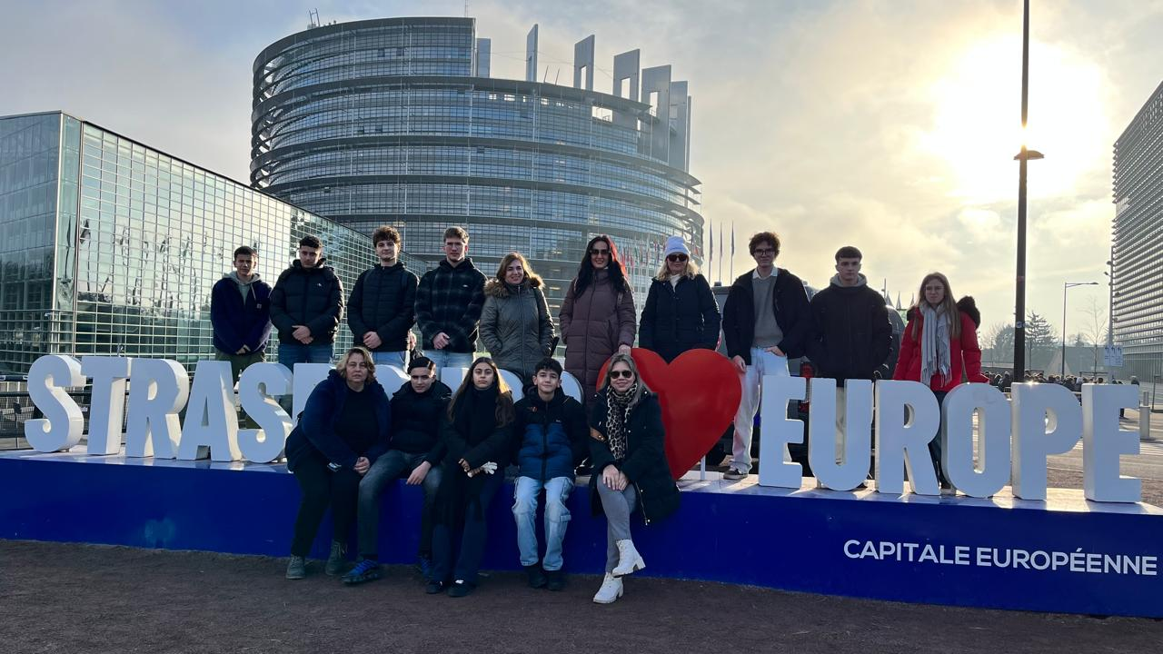
The significance of this
The program in Strasbourg formed a coherent whole:
- the analysis of sustainable urban examples,
- the academic elaboration of the project results,
- getting to know European institutions,
- as well as the European multiplication (dissemination) of the results,
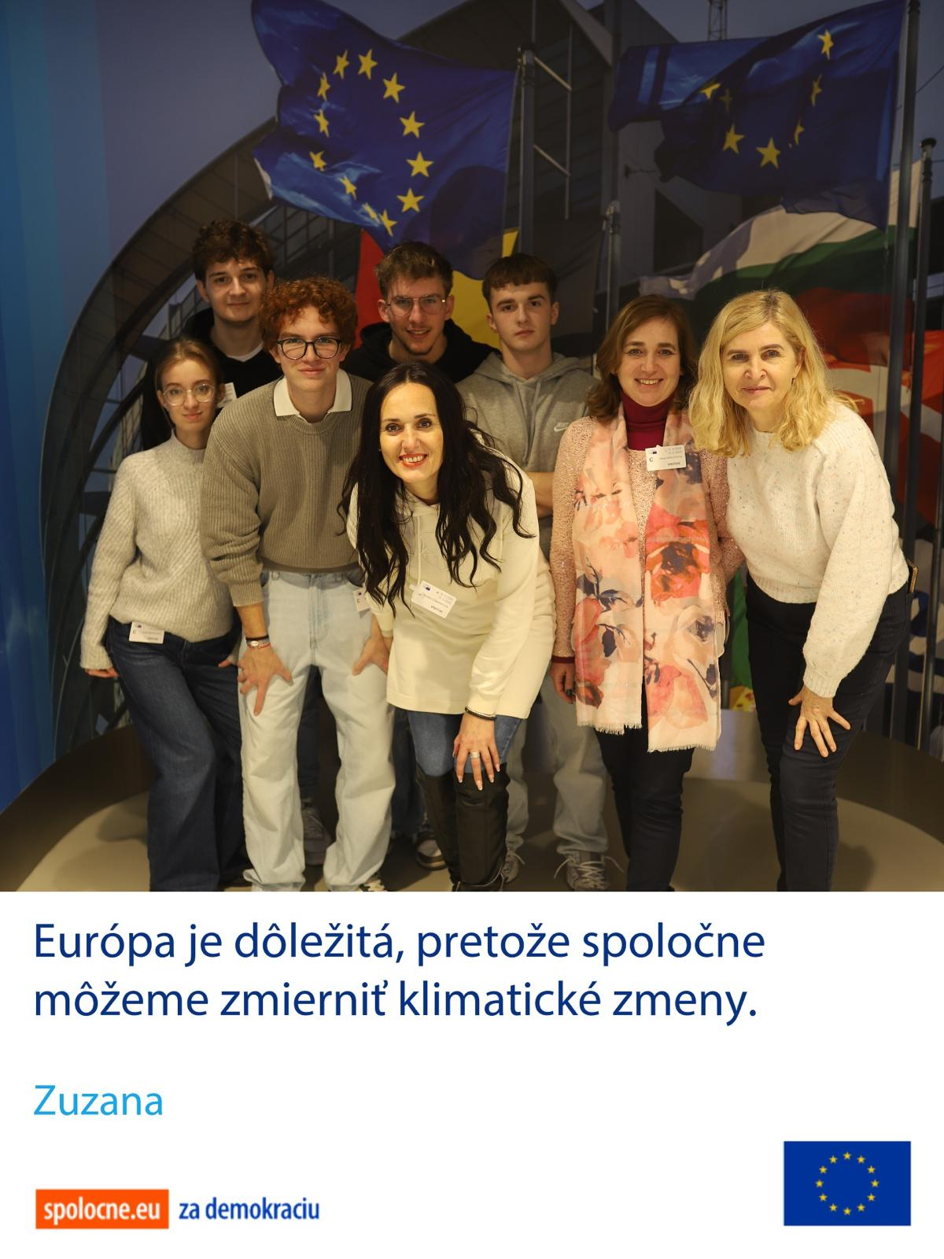
all jointly pursuing the goal of strengthening sustainable thinking and active European citizenship.
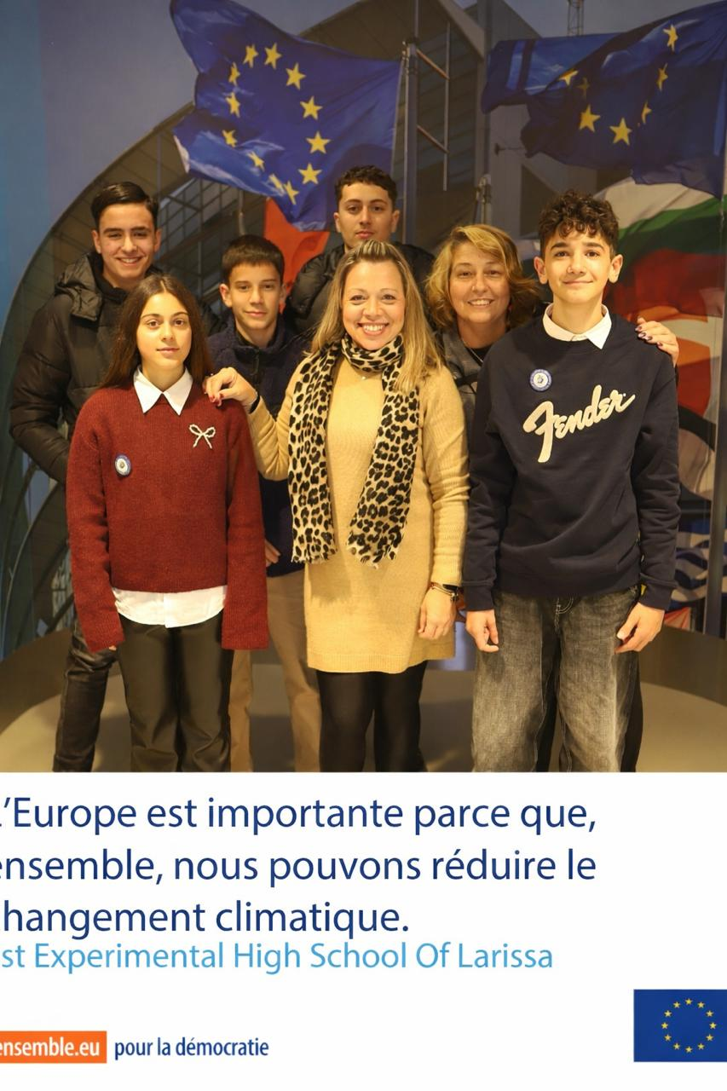
The presentation of the project at the European Parliament constituted both a symbolically and academically outstanding conclusion to the 24-month collaboration, demonstrating that school-based sustainability initiatives are also relevant within the European context and can be further developed.

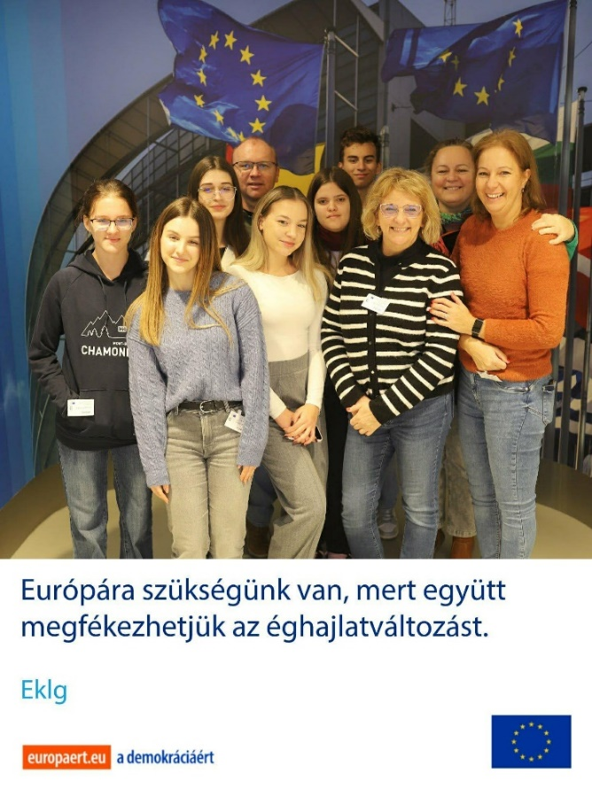
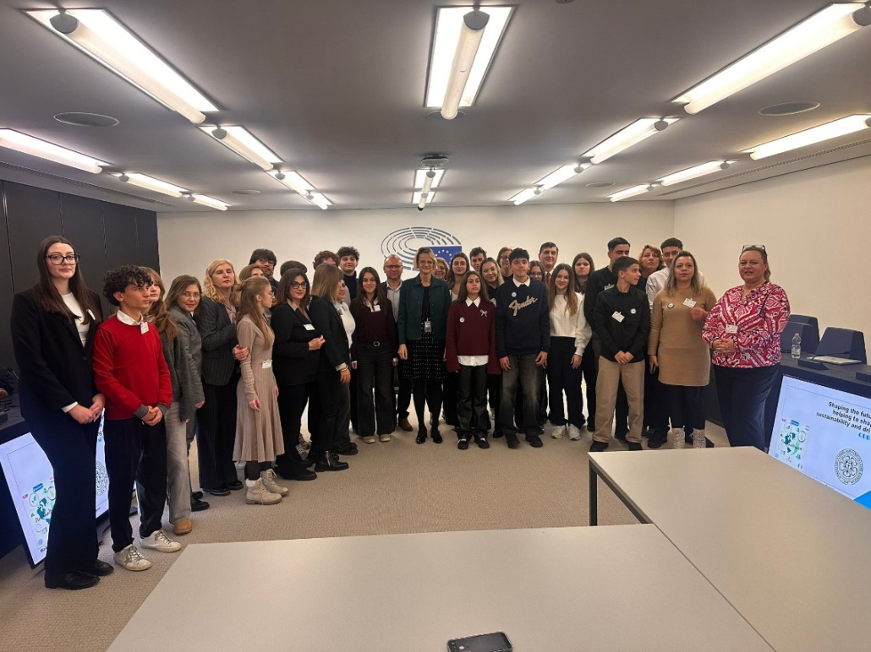

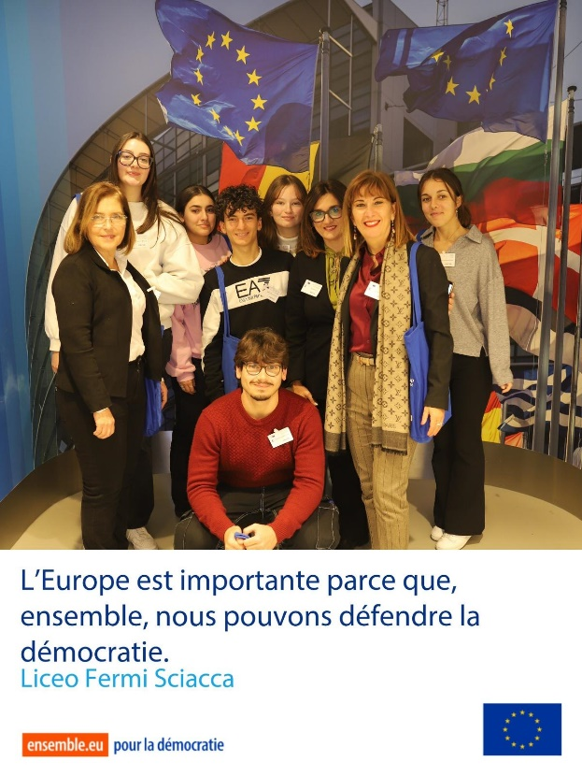

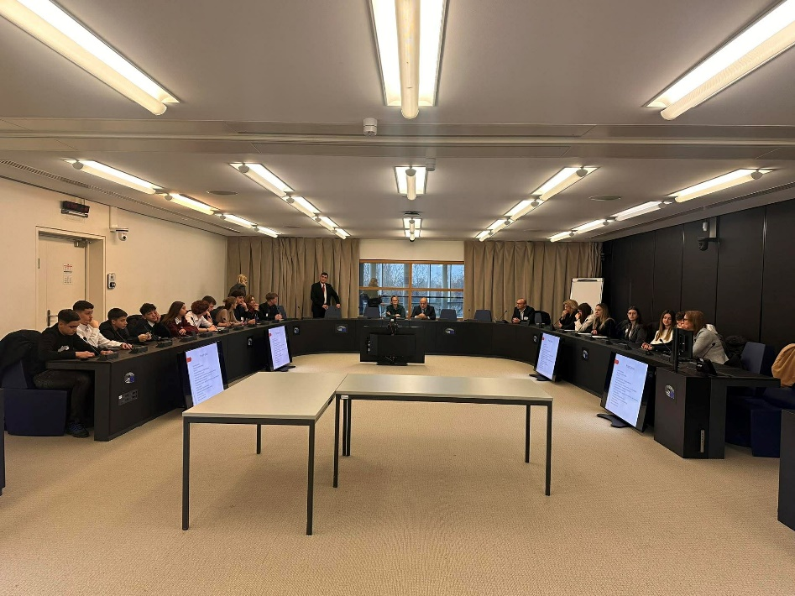
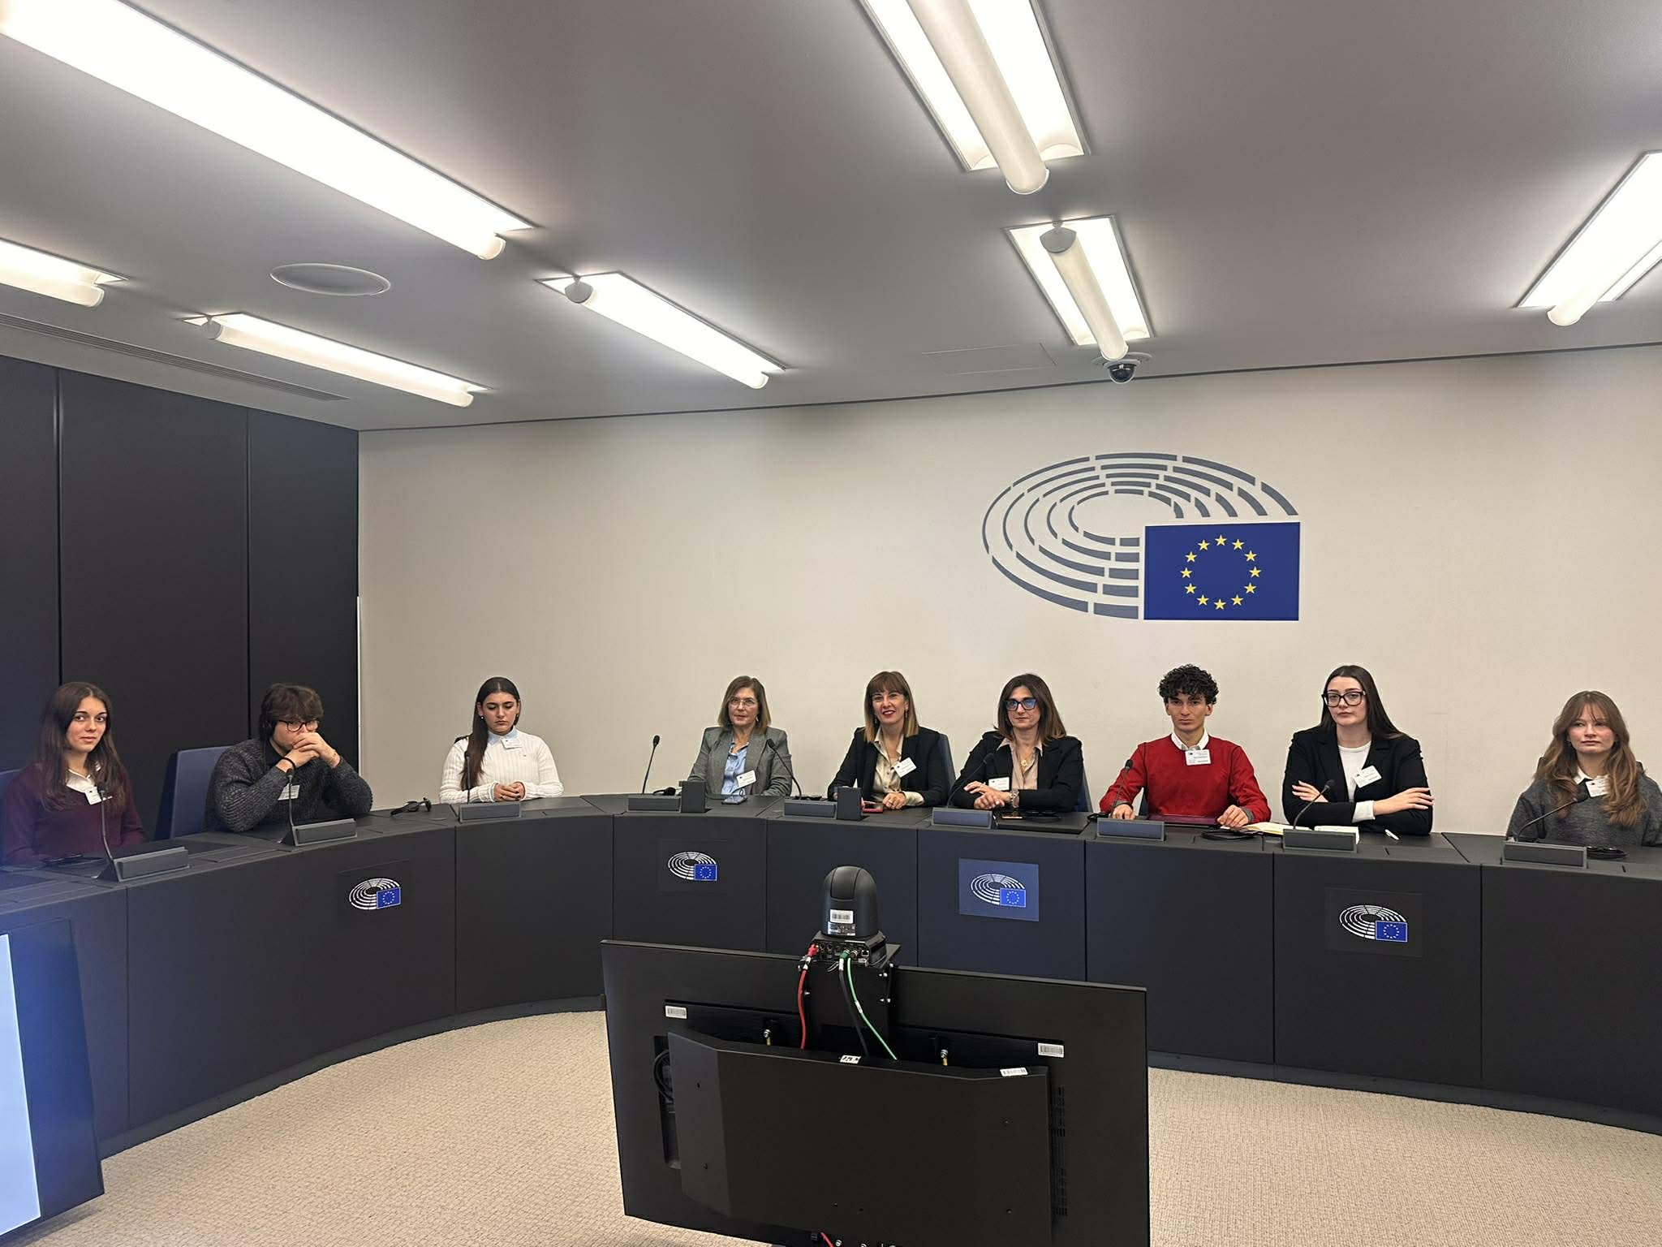

https://www.tiktok.com/@gemeinsamfuerdiezukunft/video/7600004435800100118
https://www.tiktok.com/@gemeinsamfuerdiezukunft/video/7600009073655811350
https://www.tiktok.com/@gemeinsamfuerdiezukunft/video/7608096438089813270
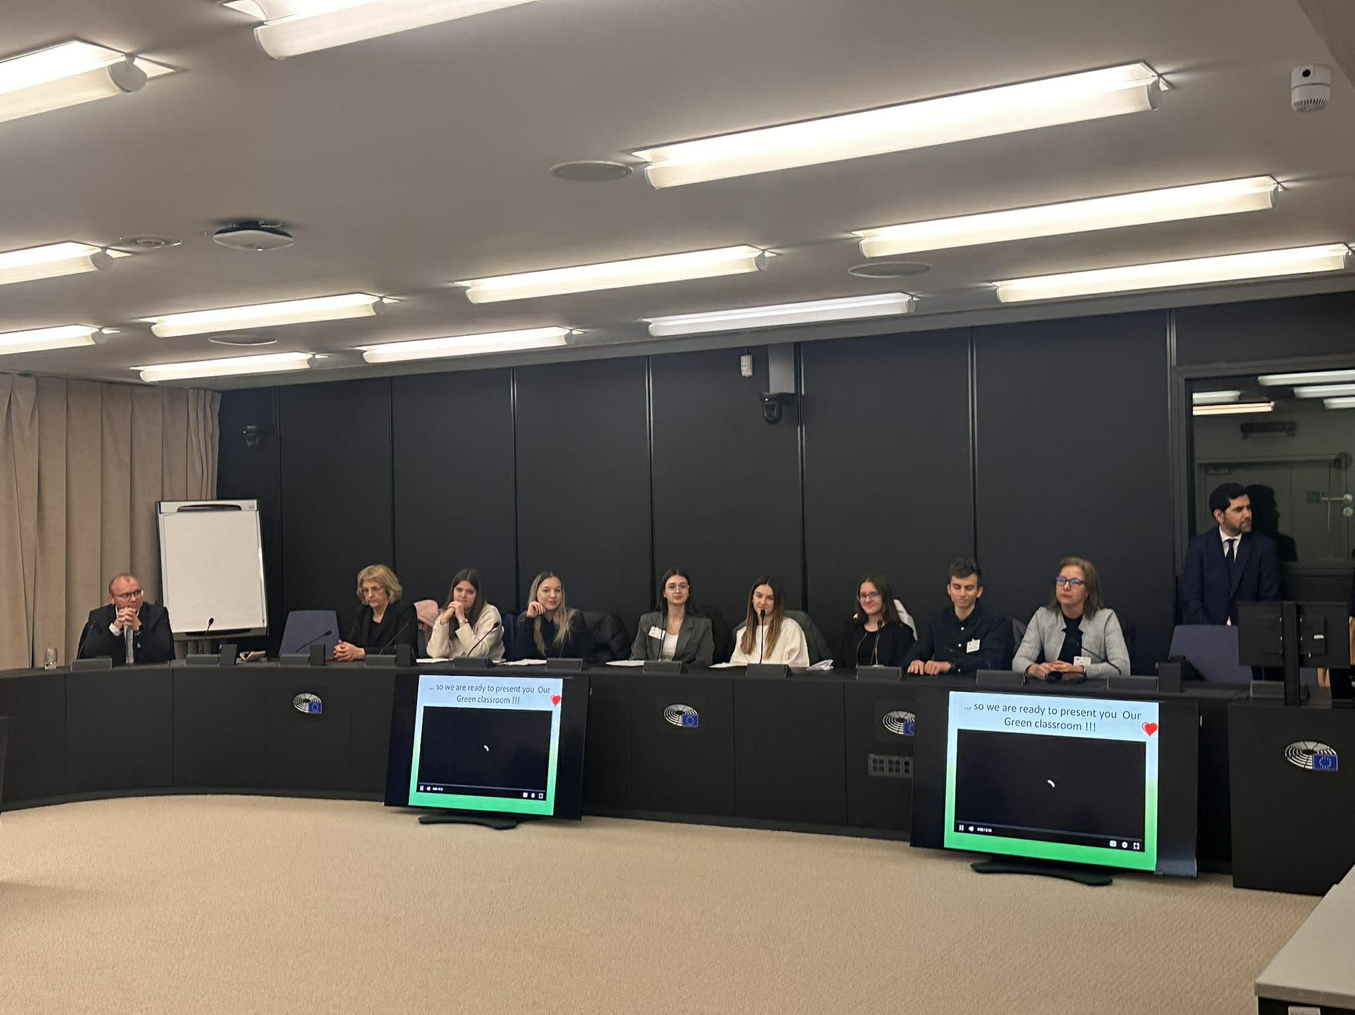

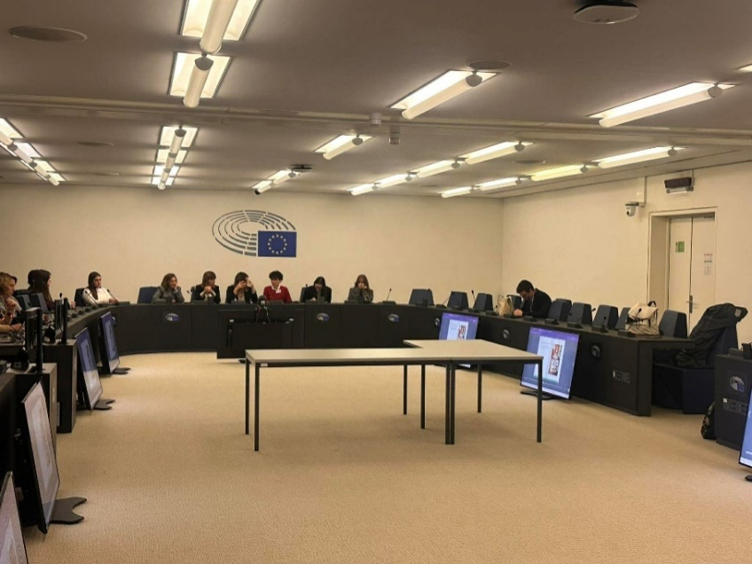
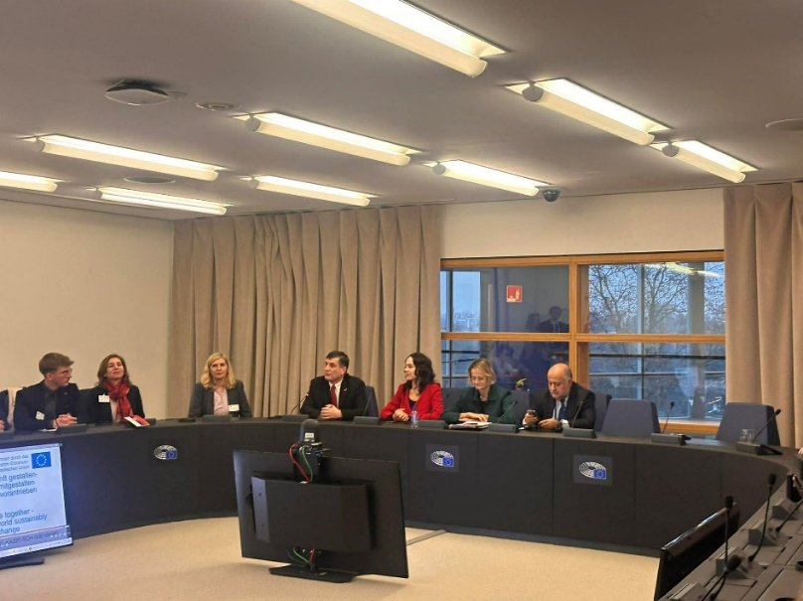

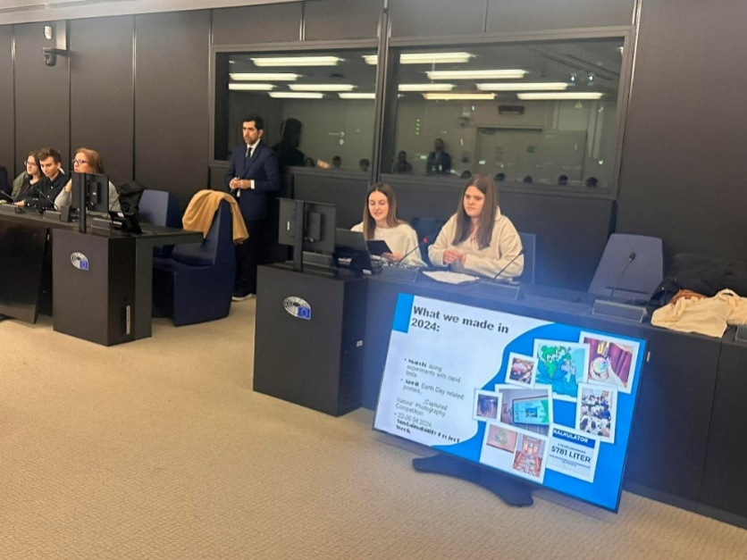

„Mit finanzieller Unterstützung der Europäischen Union. Die geäußerten Ansichten und Meinungen entsprechen jedoch ausschließlich denen der Autor*innen und spiegeln nicht notwendigerweise die der Europäischen Union oder der Tempus Közalapítvány wider. Weder die Europäische Union noch die fördernde Stelle können dafür verantwortlich gemacht werden.“
Projektnummer: 2023-2-HU01-KA220-SCH-000169980

