Lesson Plan: "The Blue Gold – Understanding Water Scarcity"
Topic: Water Management, Agriculture, and Global Sustainability
Resource: https://www.ted.com/talks/balsher_singh_sidhu_are_we_running_out_of_clean_water
Target Group: Secondary School Students (Ages 12–16)
CEFR Level: B1 (Intermediate)
Duration: 90 minutes

I. Teacher’s Lesson Outline
Time | Phase | Activity Description | Learning Objective
0-10' | Warm-up | "The Water Diary": Students estimate how many liters of water they used this morning (shower, toilet, breakfast). | Real-life connection
10-25' | Screening | Watching the TED Talk. Focus: Where is our water actually going? | Identifying main ideas
25-45' | Transcript Search | Using the official transcript to find simple data, numbers, and key vocabulary. | Scanning for information
45-80' | The Debate | "The Water Jury": A structured discussion on how to save water (Individual vs. Industrial). | Expressing opinions
80-90' | Action Plan | "The 10% Challenge": Designing a poster on how to reduce school water use by 10%. | Creative application

II. Student Workbook: 50-Item Challenge (B1 Level)
Part 1: Basic Vocabulary & Definitions (Items 1-10)
Match the words from the talk with their easier meanings:
- Scarcity ( ) | 2. Agriculture ( ) | 3. Glacier ( ) | 4. Pollution ( ) | 5. Consumption ( ) | 6. Resource ( ) | 7. Irrigation ( ) | 8. Drought ( ) | 9. Groundwater ( ) | 10. Sustainable ( )
- A. A long period of time with no rain.
- B. Water found under the earth's surface.
- C. When there is not enough of something.
- D. Providing water to crops (plants) on farms.
- E. Farming and growing food.
- F. Something that can be used for a long time without running out.
- G. A large, moving mass of ice.
- H. Dirty or harmful things in the air or water.
- I. The act of using or eating something.
- J. Something useful that we can use (like water or oil).
Part 2: Fact-Finding from the Transcript (Items 11-25)
Find these numbers and facts in the text:
- What percentage of Earth's water is freshwater? __________
- Most of the freshwater is "locked away" in which two places? __________ and __________
- How many people in the world already live in water-stressed areas? __________
- Agriculture (farming) uses about __________% of all the world’s freshwater.
- How many liters of water are needed to produce just one kilo of beef? __________
- How many liters of water does a single cup of coffee "cost"? __________
- By the year __________, half of the world's population might live in water-stressed areas.
- Name one country mentioned that is facing high water stress: __________
- We use water not just for drinking, but mostly for growing __________.
- The speaker mentions "Virtual Water." What does this mean simply? __________
- Does the speaker think we are actually "running out" of water molecules? (Yes/No) __________
- What is the main problem: the amount of water or the distribution? __________
- How much of our global water use is for industrial purposes? __________
- Name one way farmers can save water mentioned in the talk: __________
- How much water does an average person drink per day compared to what they eat? __________
Part 3: Simple Comprehension (Items 26-35)
Check if the sentence is True (T) or False (F) according to Balsher Singh Sidhu:
- All the water on Earth is available for us to drink. ( )
- Climate change makes it harder to predict when it will rain. ( )
- Eating less meat can help save large amounts of water. ( )
- Moving water from one place to another is always easy and cheap. ( )
- Pollution makes existing freshwater unusable. ( )
- The speaker says we should stop using water for farming completely. ( )
- Technology (like desalination) is the only solution we need. ( )
- Many people don't realize how much water is in their food. ( )
- Groundwater levels are going up in most places. ( )
- Our "water footprint" is mostly hidden in the things we buy. ( )
Part 4: Useful Phrases for Debate (Items 36-45)
Choose the right phrase to complete the sentence:
- "In my opinion..." is used to __________ (Start an idea / End a talk).
- "I agree with you, but..." is used to __________ (Say yes / Say yes and no).
- "For example..." is used to __________ (Give a reason / Give an illustration).
- "Firstly... Secondly..." helps to __________ (Organize ideas / Ask a question).
- "What do you think about..." is used to __________ (Give an answer / Ask for an opinion).
- Find a sentence in the transcript where the speaker says "The problem is...".
- How does the speaker use "imagine" to help the audience? __________
- Find the word "however" – what does it show? (Addition / Contrast).
- Why does the speaker use the word "we" so often? __________
- How does the talk end? (With a warning / With a call to action).
Part 5: The Debate - Saving the Blue Gold (Items 46-50)
Argue for or against these points using the B1 Debate Checklist (State idea -> Give reason -> Give example):
- Topic 1: "Governments should make water very expensive so people don't waste it."
- Topic 2: "It is more important to change our diet (less meat) than to take shorter showers."
- Topic 3: "Rich countries should pay for water technology in poor countries."
- Topic 4: "Is it fair to grow "water-heavy" crops (like almonds or cotton) in dry deserts?"
- Topic 5: "Should schools ban plastic water bottles to protect the water cycle?"

„Mit finanzieller Unterstützung der Europäischen Union. Die geäußerten Ansichten und Meinungen entsprechen jedoch ausschließlich denen der Autor*innen und spiegeln nicht notwendigerweise die der Europäischen Union oder der Tempus Közalapítvány wider. Weder die Europäische Union noch die fördernde Stelle können dafür verantwortlich gemacht werden.“
Projektnummer: 2023-2-HU01-KA220-SCH-000169980
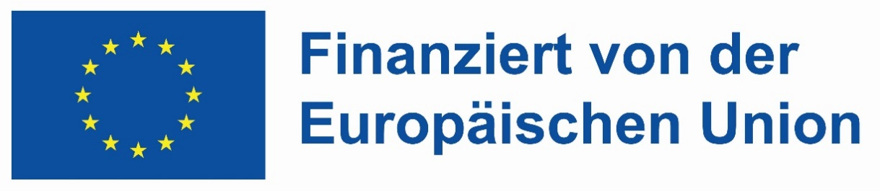

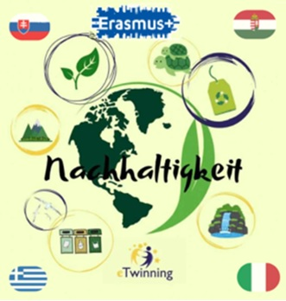

III. Teacher's Answer Key
- 1-10: 1-C, 2-E, 3-G, 4-H, 5-I, 6-J, 7-D, 8-A, 9-B, 10-F.
- 11-25: 11: ~3%. 12: Ice caps/Glaciers and Groundwater. 13: Over 2 billion. 14: 70%. 15: ~15,000 liters. 16: ~140 liters. 17: 2025/2030. 18: India/Mexico/etc. 19: Food. 20: Water used to produce products. 21: No. 22: Distribution/Management. 23: ~20%. 24: Drip irrigation/better crop choice. 25: We drink 2-4 liters but "eat" thousands.
- 26-35: 26-F, 27-T, 28-T, 29-F, 30-T, 31-F, 32-F, 33-T, 34-F, 35-T.
- 36-40: 36-Start, 37-Yes and no, 38-Illustration, 39-Organize, 40-Ask opinion.
- 41-45: (Based on transcript cues: Problem is management, Imagine a world without, Contrast, Collective responsibility, Cooperation).

