Lesson Plan: "The Fabric of Our Future"
Topic: Sustainable Fashion, Supply Chain Transparency, and Ethical Design
Resource: https://www.ted.com/talks/amy_powney_how_to_fix_fashion_and_protect_the_planet
Target Group: Secondary School Students (Ages 14–18)
CEFR Level: B2 (Upper-Intermediate)
Duration: 90 minutes

I. Teacher’s Lesson Outline
Time | Phase | Activity Description | Learning Objective
0-10' | Introduction | "The Label Audit": Students check their own clothing labels for "Made in..." and material composition. | Personal engagement
10-25' | Screening | Watching the TED Talk. Focus: Identifying the hidden costs of the fashion industry. | Information gathering
25-45' | Transcript Work | Analyzing the official transcript: Scanning for specific data points and professional terminology. | Reading comprehension
45-85' | The Grand Debate | "The Sustainability Jury": A structured debate using the Sustainability Matrix (Economic/Ecological/Social). | Argumentation skills
85-90' | Reflection | "The Fashion Pledge": Writing one concrete step to change personal consumption habits. | Synthesis

II. Student Workbook: 50-Item Challenge
Part 1: Vocabulary & Supply Chain Terminology (Items 1-10)
Match the professional terms used in the talk with their definitions:
- Supply chain ( ) | 2. Offshoring ( ) | 3. Raw material ( ) | 4. Greenwashing ( ) | 5. Traceability ( ) | 6. Landfill ( ) | 7. Organic ( ) | 8. Biodiversity ( ) | 9. Carbon footprint ( ) | 10. Circular economy ( )
- A. Deceptively making a company appear more environmentally friendly than it is.
- B. The entire network of entities involved in producing and delivering a product.
- C. Relocating production to another country to reduce costs.
- D. The capacity to track every stage of a product’s lifecycle.
- E. Basic substances used to create goods (e.g., cotton, wool).
- F. An economic system aimed at eliminating waste and the continual use of resources.
- G. The total amount of greenhouse gases generated by our actions.
- H. A site for the disposal of waste materials by burial.
- I. Produced without the use of chemical fertilizers or pesticides.
- J. The variety of plant and animal life in a particular habitat.
Part 2: Fact-Finding from the Transcript (Items 11-25)
Analyze the text carefully to find the specific data mentioned by Amy Powney:
- What is the total number of clothing items produced globally each year? __________
- What percentage of these clothes is recycled back into new garments? __________
- Where did Amy grow up (living "off-the-grid" in a caravan)? __________
- What was the specific name of the prize she won from Vogue? __________
- Before her changes, a standard garment traveled to how many countries? __________
- Amy found her sustainable wool source on a farm in which country? __________
- The sheep on this farm are __________-certified (ensuring humane treatment).
- She located a mill that operates on renewable energy in which country? __________
- Sustainable denim production requires the use of __________ cotton.
- Amy uses a metaphor: the industry produces enough clothes to fill __________.
- What wood-based fiber did she choose from sustainable forests? __________
- Which specific stage of garment production is the most water-polluting? __________
- In which country did she find a factory that recycles 100% of its water? __________
- Her collection’s buttons were crafted from __________ (a natural nut).
- She substituted traditional polyester with __________ polyester made from bottles.
Part 3: Deep Comprehension & Analysis (Items 26-35)
Decide if the statements are True (T) or False (F) based on the talk. Justify your answer:
- The term "sustainable" is currently a legally protected and strictly defined term. ( )
- Amy felt like a "detective" because global supply chains are intentionally hidden. ( )
- Truly sustainable fashion is always double the price of high-street fast fashion. ( )
- Traditional industry suppliers were eager to share their source information. ( )
- Amy believes that new technology alone is enough to solve the climate crisis. ( )
- The fast fashion business model relies on the concept of clothes being "disposable." ( )
- Amy’s "No-Compromise" project was fully completed within two months. ( )
- Amy insists that every person in her supply chain must be paid a "living wage." ( )
- Sending unwanted clothes to charity is always better than reducing consumption. ( )
- The core of Amy’s message is that we simply need to "slow down" consumption. ( )
Part 4: The Toolkit for Professional Debate (Items 36-45)
Connect the linguistic phrase to its specific function in a formal debate:
- "While I acknowledge your point, I must argue..." ( ) | A. Starting an argument
- "The data provided in the transcript proves..." ( ) | B. Polite disagreement
- "To conclude our team's position on this issue..." ( ) | C. Citing evidence/facts
- "Could you please clarify your stance on..." ( ) | D. Summarizing/Closing
- "Furthermore, it is vital to consider..." ( ) | E. Requesting clarification
- Describe the personal story Amy tells to establish her credibility. __________
- Identify one shocking statistic she uses to create a sense of urgency. __________
- Find an example of inclusive language (we/us) in her concluding remarks. __________
- How does Amy define the concept of "Transparency" in her work? __________
- What is the specific "Call to Action" she leaves for the audience? __________
Part 5: Structured Debate Prompts (Items 46-50)
Prepare your arguments for the following topics using the Sustainability Matrix (Economic, Ecological, Social):
- Topic 1: "It is the consumer's moral duty, not the company's, to research and choose better."
- Topic 2: "Fast fashion is a social necessity because it makes trends affordable for lower-income groups."
- Topic 3: "Governments must pass laws to ban the burning of unsold seasonal clothing stock."
- Topic 4: "Is 'Sustainable Fashion' by a large corporation real progress or just greenwashing?"
- Topic 5: "Can any global fashion brand truly be 100% sustainable in a modern economy?"
„Mit finanzieller Unterstützung der Europäischen Union. Die geäußerten Ansichten und Meinungen entsprechen jedoch ausschließlich denen der Autor*innen und spiegeln nicht notwendigerweise die der Europäischen Union oder der Tempus Közalapítvány wider. Weder die Europäische Union noch die fördernde Stelle können dafür verantwortlich gemacht werden.“
Projektnummer: 2023-2-HU01-KA220-SCH-000169980
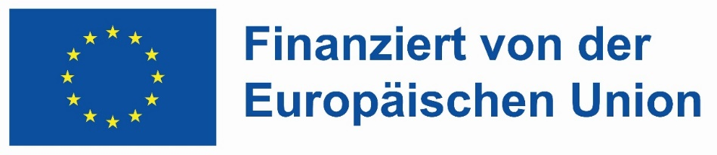
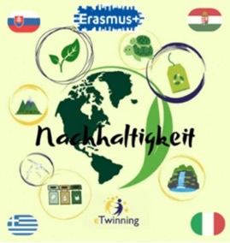

III. Teacher's Comprehensive Answer Key
- 1-10: 1-B, 2-C, 3-E, 4-A, 5-D, 6-H, 7-I, 8-J, 9-G, 10-F.
- 11-25: 11: 100 billion. 12: Less than 1%. 13: North of England. 14: Vogue Fashion Fund. 15: 5 to 10. 16: Uruguay. 17: Mulesing-free/GOTS. 18: Austria/Turkey. 19: Organic. 20: Landfills. 21: Tencel/Lyocell. 22: Dyeing. 23: Portugal. 24: Corozo. 25: Recycled.
- 26-35: 26: F (It is not legally defined). 27: T. 28: F (Streamlining can keep prices competitive). 29: F. 30: F. 31: T. 32: F (It took nearly three years). 33: T. 34: F. 35: T.
- 36-45: 36-B, 37-C, 38-D, 39-E, 40-A. 41: Growing up without running water/power. 42: 100 billion items. 43: "Our planet, our responsibility." 44: Knowing every person/place in the chain. 45: Ask "Who made my clothes?".

