Project: "Chokepoints & Challenges – The Geopolitics of Energy"
Topic: Energy Security, Geopolitics, and the Sustainability Transition
Resource: https://www.youtube.com/watch?v=udtVdDmSSoo
Target Group: Ages 15–18 (B2 Level)
Duration: 90 minutes
I. Detailed Lesson Procedure (Teacher's Guide)
Time | Phase | Activity Description | Learning Objective
0-15' | Mapping | "Where is the Oil?" – Students identify the Strait of Hormuz on a map and guess what % of world oil passes through it. | Contextualization
15-30' | Screening | Watching the video. Students complete the "Fact-Checker" table. | Data Acquisition
30-50' | Analysis | "The Domino Effect" – Group discussion on how a local conflict becomes a global price shock. | Critical Thinking
50-80' | The Shift | "Sustainability as Security" – Role-play: Planning a national energy strategy to avoid "chokepoints". | Problem Solving
80-90' | Summary | Writing a 3-sentence "Policy Recommendation" for the EU. | Synthesis

Student Workbook: The Geopolitics of Energy (Strait of Hormuz)
Resource: The Strait of Hormuz Explained
Part 1: Vocabulary & Geography
Match the terms (1-10) with definitions (A-J), and label the map locations (11-15).
- Chokepoint ( ) | 2. Territorial Waters ( ) | 3. Crude Oil ( ) | 4. Transit ( ) | 5. Tensions ( ) | 6. Bypass ( ) | 7. Memorandum ( ) | 8. Vessel ( ) | 9. Barrel ( ) | 10. Sanctions ( )
- A. Unprocessed oil directly from the ground.
- B. A narrow passage where traffic can be easily blocked.
- C. To go around something.
- D. A large ship or boat.
- E. Sea areas belonging to a specific country (12 nautical miles).
- F. The act of passing through a place.
- G. Political or military strain between nations.
- H. A unit of volume for oil (approx. 159 liters).
- I. Penalties applied by one country to another.
- J. An official diplomatic agreement.
Map Labeling
  - Persian Gulf | 12. Gulf of Oman | 13. Arabian Sea | 14. Red Sea | 15. Strait of Hormuz
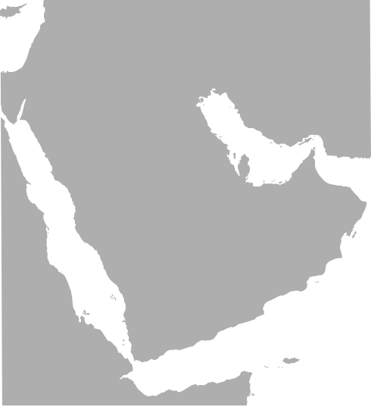

Part 2: Fact-Checking & Numbers
Circle the correct data based on the video [00:01:40 - 00:02:10]:
- Average daily oil flow: ( 15 / 21 / 30 ) million barrels.
- One barrel equals: ( 100 / 159 / 200 ) liters.
- Total daily volume equals over: ( 500 / 1,000 / 1,300 ) Olympic swimming pools.
- Percentage of world's daily petroleum: ( 10% / 21% / 50% ).
- Share of global sea-transited oil: ( 1/4 / 1/3 / 1/2 ).
- Share of traded natural gas: ( 10% / 25% / 40% ).
- Narrowest width of the strait: ( 21 km / 39 km / 55 km ).
- Percentage of oil heading to Asia: ( 50% / 76% / 90% ).
- Number of main Asian importer countries mentioned: ( 3 / 5 / 7 ).
- Saudi pipeline capacity (max): ( 1 / 5 / 10 ) million barrels per day.

Part 3: Deep Listening - True or False
Decide if the statements are True (T) or False (F). Correct the false ones!
- The strait is deep enough for the world's largest tankers. ( )
- Shipping lanes start in the territorial waters of Oman. ( )
- Some islands in the strait are claimed by both Iran and the UAE. ( )
- Most oil passing through the strait goes to Europe and the USA. ( )
- To reach East Asia, tankers often pass through the Strait of Malacca as well. ( )
- The Strait of Hormuz is wide enough to be considered international high seas. ( )
- Saudi Arabia can bypass the strait using the East-West pipeline to the Red Sea. ( )
- The UAE pipeline ends in the Persian Gulf. ( )
- All existing pipelines in the region are currently used at 100% capacity. ( )
- The future stability of the strait depends on global "hunger for oil". ( )

Part 4: Logical Mapping & The "Sustainability Link"
Fill in the gaps to complete the "Fossil Fuel Domino Effect" flow-chart:
- Geopolitical conflict starts in the __________ __________.
- Oil tankers are blocked or __________.
- Global supply of oil __________ (increases/decreases).
- The price of one barrel of crude oil __________ (skyrockets/drops).
- Cost of fuel for trucks and ships becomes __________.
- Price of imported food in your local shop __________.
- Inflation affects the __________ of citizens.
- Conclusion: High dependency on foreign oil makes our economy __________ (stable/fragile).
- Solution 1: Switching to __________ energy reduces dependency on chokepoints.
- Solution 2: Improving __________ efficiency reduces the total need for oil.

Part 5: Action & Debate
Critical thinking questions for group work:
- List 2 reasons why solar power is "safer" for a country than oil.
- Why is the Strait of Hormuz called a "chokepoint"? (Metaphorical explanation).
- What is "Embodied Energy" in the context of shipping?
- If you were the Governor of a country, would you invest in a pipeline or a wind farm? Give 1 reason.
- Write a 1-sentence slogan for a campaign promoting energy independence.

„Mit finanzieller Unterstützung der Europäischen Union. Die geäußerten Ansichten und Meinungen entsprechen jedoch ausschließlich denen der Autor*innen und spiegeln nicht notwendigerweise die der Europäischen Union oder der Tempus Közalapítvány wider. Weder die Europäische Union noch die fördernde Stelle können dafür verantwortlich gemacht werden.“
Projektnummer: 2023-2-HU01-KA220-SCH-000169980
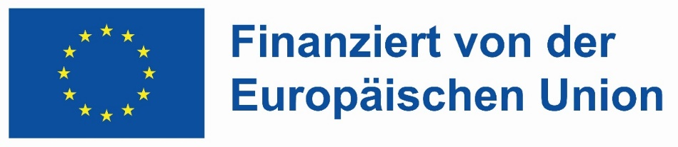
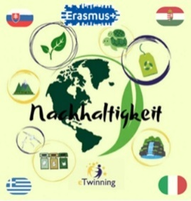

Teacher’s Key
- 1-10: 1-B, 2-E, 3-A, 4-F, 5-G, 6-C, 7-J, 8-D, 9-H, 10-I.
- 16-25: 16: 21m, 17: 159L, 18: 1,300, 19: 21%, 20: 1/3, 21: 25%, 22: 39km, 23: 76%, 24: 5, 25: 5m.
- 26-35: 26:T, 27:F (Iran), 28:T, 29:F (Asia), 30:T, 31:F (Territorial), 32:T, 33:F (Gulf of Oman), 34:F (Underused), 35:T.
- 36-45: 36: Persian Gulf/Hormuz, 37: attacked/delayed, 38: decreases, 39: skyrockets, 40: higher, 41: increases, 42: budget/lifestyle, 43: fragile, 44: renewable, 45: energy.

