




--Let'sDiscoverBioplasticsandP'lants!

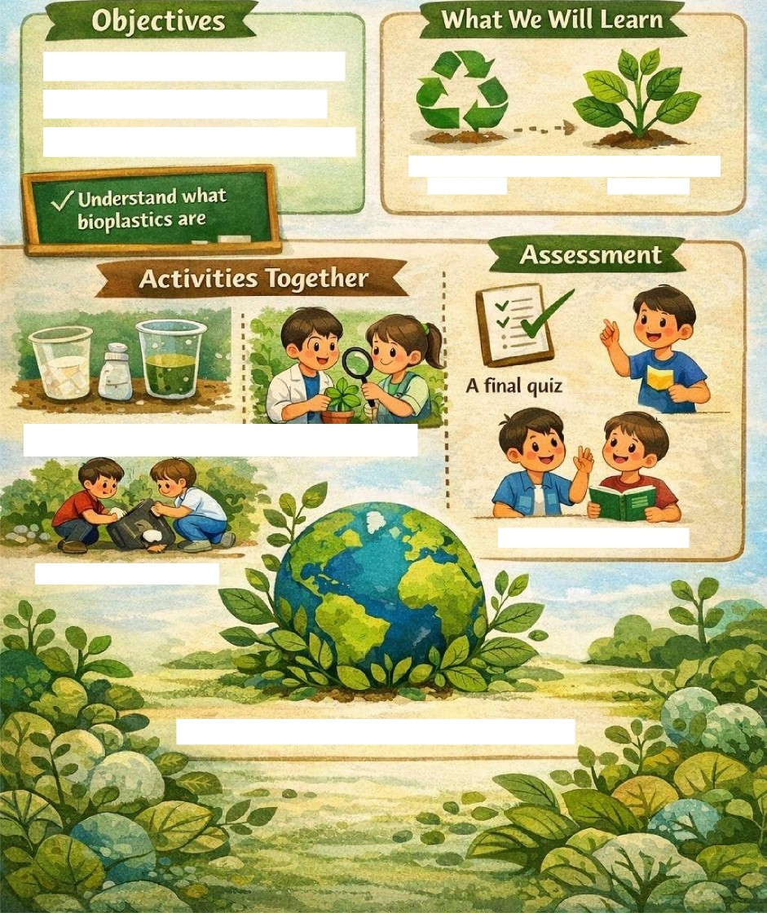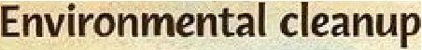
t\{nd.e‹a%“wfiatbispbsticsare.
Discoverthebenefitsofplants
iiq s:oiasi:is’ are made
Thv’›q;iw@;itsInh!atiIie

„GemeinsamdieZukunftgestalten-nachhaltigdieWeltmitgestaltenund Veränderungenvorantrieben“

- Objectives

Objectivesindicatewhatwewantstudentstolearnanddevelop.
Understand what bio-plastic is → Students should learn that there is a type of plastic made from plants, which is biodegradable and less polluting than traditional plastic.
● Discover the benefits of plants → Understand how plants contribute to the environment, for example by producing oxygen, improving soil, or serving as raw materials for sustainable products.
● Learn to protect the environment → Students develop awareness of how their daily actions affect nature and sustainability

- Content

Contentreferstotheinformationandknowledgetobelearned.

How bio-plastic is made → Types of plants used (corn, potatoes, algae), simple production processes, and practical applications.
● The role of plants in nature → Functions of roots, leaves, stems, and flowers; importance for biodiversity and oxygen production.
● Environmental impact of plastic → Difference between traditional plastic and bio-plastic, and how to reduce pollution. ● Examples from Erasmus countries → Environmental initiatives in Italy, Slovakia, Greece, and Hungary.

- Activities

Activitieshelpputlearningintopractice.

Bio-plastic experiments → Create small amounts of bio-plastic using simple materials to understand the process and observe how it works.
● Botany workshop → Observe plants, identify their parts, and understand which ones can be used to produce bio-plastic.
● Environmental clean-up → Practical sustainability actions, such as collecting waste or planting seeds.
● International collaboration → Compare practices and experiences from the four participating countries (Italy, Slovakia, Greece, and Hungary) through video calls or shared posters.
● Final project → Students created bio-plastics outdoors, in the sustainable classroom of our school, built thanks to the Erasmus project and the funds received.

- Assessment
Assessment is used to check whether students have understood and applied the knowledge.
● Final quiz → Simple questions about bio-plastic, plants, and sustainability.
● Group Q&A → Compare answers among students to encourage understanding and discussion.
● Final project evaluation → Assess whether the poster/video shows clarity, scientific accuracy, and collaboration among students from different countries. 5. Expected Results Expected results are the concrete benefits of the learning unit.
● Knowledge of plants used for bio-plastic → Students know which plants can be used and why.
● Environmental awareness → They understand the impact of traditional plastic and how to reduce it using sustainable alternatives.
● Collaborative and communication skills → Improved ability to work in groups, including with students from other countries, and to share ideas clearly.
● Motivation to protect the environment → Encouragement to take concrete actions for a greener future.

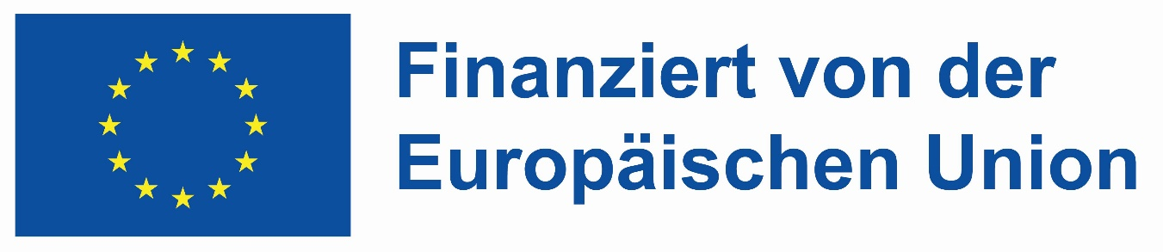

„Mit finanzieller Unterstützung der Europäischen Union. Die geäußerten Ansichten und Meinungen entsprechen jedoch ausschließlich denen der Autor*innen und spiegeln nicht notwendigerweise die der Europäischen Union oder der Tempus Közalapítvány wider. Weder die Europäische Union noch die fördernde Stelle können dafür verantwortlich gemacht werden.“
Von der Europäischen Union finanziert – Projektnummer: 2023-2-HU01-KA220-SCH-000169980

