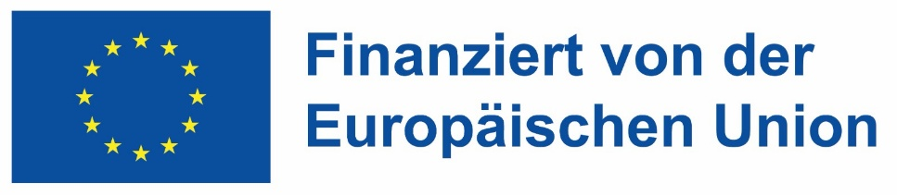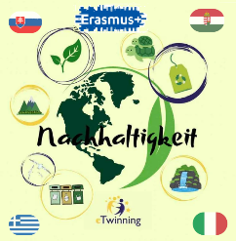
„Mit finanzieller Unterstützung der Europäischen Union. Die geäußerten Ansichten und Meinungen entsprechen jedoch ausschließlich denen der Autor*innen und spiegeln nicht notwendigerweise die der Europäischen Union oder den Tempus Közalapítvány wider. Weder die Europäische Union noch die fördernde Stelle können dafür verantwortlich gemacht werden.“
Projektnummer: 2023-2-HU01-KA220-SCH-000169980

Liceo Schientifico Statale “Enrico Fermi” – Sciacca
Civic Education Teaching Unit “Environmental Sustainability”
Unit 1: Blue Gold – Importance and Conservation of Water
Objective: To develop awareness of the scarcity of water resources and the impact of invisible consumption.
Learning objectives:
- Describe the water cycle and the distribution of freshwater on Earth.
- Identify behaviors to reduce water waste.
Proposed activities:
- Invisible Water (Water Footprint): Analyze how much water is needed to produce common goods (e.g., 2,500 liters for a pair of jeans). Students create a "low water consumption menu."
- Faucet Detective: An experiment at home or at school. Place a container under a leaking faucet and calculate how much water is wasted in 24 hours, translating it into annual liters.

Unit 2: From the Table to the Planet – The Circular Economy
Objective: Move from the "produce-use-dispose" model to one of recycling and reuse, focusing on food waste.
Learning objectives:
- Distinguish between linear and circular economy.
- Understand the connection between food, energy, and waste.
Proposed activities:
- Upcycling Workshop: Transform packaging destined for the trash (bottles, cardboard boxes) into new useful objects for the class (pen holders, plant pots).
- The Waste Diary: For one week, students note what is thrown in the household trash and look for alternatives (e.g., using apple peels for an infusion or stale bread for a recipe).

Unit 3: Green Play – Sustainable Sport
- Objective: Recognize the environmental impact of sports activities and promote an active lifestyle that respects the planet.
Learning objectives:
- Analyze the life cycle of sports equipment (synthetic vs. natural materials).
- Understand the impact of major sporting events (waste, transport, energy consumption).
- Promote "0 Km Sport" and outdoor movement.
Proposed activities:
- Bag Analysis (Simplified LCA): Students ideally empty their sports bag. What is the shirt made of? (Polyester/Microplastics). The label is analyzed to understand the journey the object has made and how difficult it is to recycle.
- Plogging Challenge: A practical activity that combines jogging and waste collection (pick up + jogging). A short outing is organized in the school courtyard: the winner is whoever collects the

